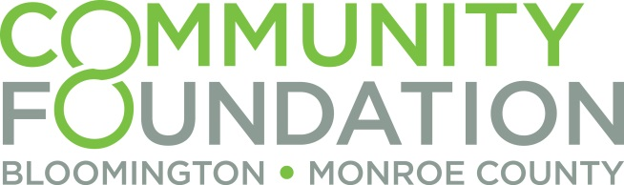

Impact Investment Questionnaire
Inquiry questionnaires should be submitted at least 90 days before the proposed start of your project. Upon review of initial questionnaires, the impact investing committee will invite selected organizations to begin the formal process for investment evaluation. The process may take approximately 3 – 6 months from receiving the initial questionnaire to closing the investment.

Organization Name:
Address:
City:
State:
Zip code
Are you a 501(c)3 nonprofit? (Yes or No):
If yes, EIN Number:
Year Organization Founded:

Primary contact for this request:
Name:
Title:
Phone number:
Email:

Preliminary Questionnaire:
What is the mission of your organization?

Project Title:

Project Start Date:
Please share the timeline for the project and when the investment funds would be required.

Project Summary: (Brief description of project/investment. Include details such as: overall goal, location, community need/benefit addressed, relevant team members, etc.)

Geographical Area Served:

Key Audience / Target Population:

Number of People/Beneficiaries Served:

What is the anticipated social impact that will result from the investment, if received?

Investment request:
Investment Type Requested (loan, loan or lease guarantee, etc.):
Total Amount Requested:
Year 1 Amount Requested:

How much capital do you have committed from other sources? Please provide the list of capital commitments and pending requests including type of capital, amount, and terms.

What would be the source of capital for repayment of the investment? If there is any collateral or guarantee, please describe.

Do you have any existing organizational debt? If so please describe.

Please provide an attachment with profiles of key leadership / management team including the CEO, President, CFO, Board Chair, and other relevant employees.

Please provide the following financial documents:
- Most recently audited (if applicable) annual financial statements.
  - Balance sheet
  - Income and Expenses (Cash flow statement)
- Operating Budget (preferred format is Excel spreadsheet with one tab per year)
  - Current fiscal year plus three years projections
  - Please include both current loan payments and projected loan payments.
  - Note any assumptions used in forming your budget and projects
- Project presentation (readily available documents outlining project, scope, cost, etc.)

